Дегтярев А.И., МБОУ Гимназия № 2, г. Саров
Задания Интернет-конкурса «Around the world – 2019»

Dear participants! In this quiz you will have to answer 25 questions. There are no variants of answers to most of the questions. You'll have to look up the information online. Your time is limited! You have 1 hour to complete the task. You must submit your answers by 4 p.m. Type in your answers in English. Use precise language and grammar. Mind punctuation and capitalization. Let's start! Good luck!
Question 1. What parts does the UK consist of? (Tick one or several boxes to answer) (1 point) *
England
Wales
Ireland
Scotland
Northern Ireland
Britain
Question 2. Residents of the city of Churchill, Canada leave their cars in the streets open and with the key in the ignition (замок зажигания) Why? (1 point) *
so that pedestrians had the opportunity to drive if they need to
so that pedestrians had the opportunity to run away if they meet polar bears
it is a community tradition
they have bad memory
Question 3. Who is number 1 in the list of best-selling British authors? (1 point) *
Jane Austen
JK Rowling
Agatha Christie
Charlotte Brontë
Question 4. There are 1453 airports in Canada. (1 point) *
yes
no
Question 5. Union Jack is the name of... (1 point) *
a British person
the UK
the flag of the UK
the UK monarch
Question 6. This is the only European city which is still partly divided into two parts by the wall (the so-called ‘peace lines’). (2 points) *
Мой ответ
Question 7. This place is called "The city of dreaming spires". a) What city is it? b) Name the poet who called the city this way. c) A world-famous story is based on the events happened to the prototypes of its characters who lived in this city. Name the main character of the book. (3 points) *

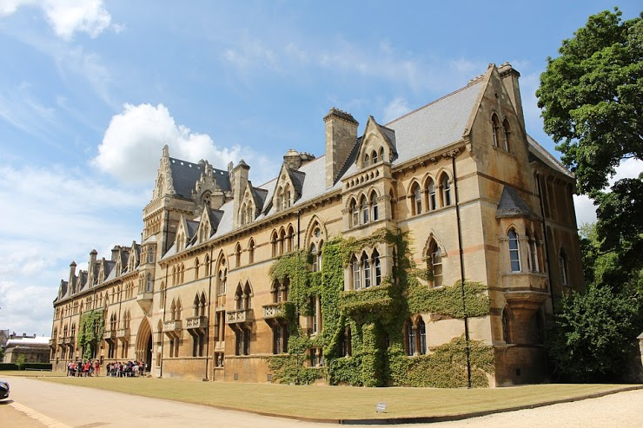
Мой ответ
Question 8. The London Eye is a top tourist attraction in London. As you know it's got a lot of capsules and each of them can hold up to 25 people. How many capsules has it got and why? (2 points) *

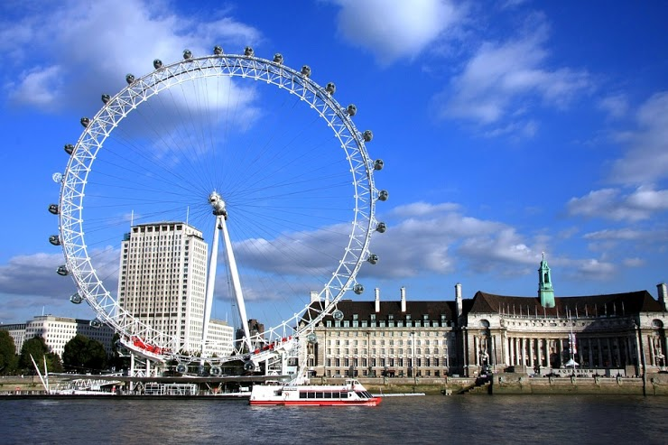

Мой ответ
Question 9. This is a unique place in London where monkeys, royal crowns, knights' armour and even a dragon can be found. What place is it? What does the dragon symbolise? What bridge can you see from its walls? (3 points) *
Мой ответ
Question 10. Do you think it is possible to travel from Dublin to London by bus? If it isn't possible, explain why. If it is, explain how. (2 points) *
Мой ответ
Question 11. It took Sir Christopher Wren 35 years to build this wonderful building. (1 point) *
Мой ответ
Question 12. Walking around Cambridge we noticed that some of the old houses had their windows bricked up. Why was it done in the 17 century? (1 point) *
Мой ответ
Question 13. All British monarchs celebrate their birthdays in June and it doesn't matter when their real birthday is. Who was the first monarch to establish this tradition and why he/she did it? (2 points) *
Мой ответ
Question 14. American sociologists call young people who are keen on gadgets ''generation D'' (from ''digital''). What two Latin letters do they use to talk about overweight people? (1 point) *
Мой ответ
Question 15. Which is another name for Australia? (1 point) *
Мой ответ
Question 16. If it's Christmas in Australia, what season is it there? (1 point)
Мой ответ
Question 17. What is the capital city of the USA? (1 point) *
Мой ответ
Question 18. How many stars and stripes does the American flag have? Why? (2 points) *
Мой ответ
Question 19. "If you want to get to Times Square in NY, you should take a traditional black taxi." What is wrong in the phrase above? (1 point) *
Мой ответ
Question 20. Alabama, Connecticut, Iowa, Kentucky, Nebraska, Utah. Why are these US States in the same group? (1 point) *
Мой ответ
Question 21. If I was in Australia eating a lamington, what would I be eating? (1 point) *
Мой ответ
Question 22. Imagine you are Londoners. You are school students. What exam are you going to have at the age of 16? (don't name the subjects, just give the name of the national examination)(1 point) *
Мой ответ
Question 23. Who is dubbed 'Bobbies', 'fuzz' and 'pigs'? (1 point) *
Мой ответ
Question 24. Where is the famous Circus du Soleil located? (country, city) What is special about it? (2 points) *
Мой ответ
Question 25. This island is called Emerald Isle. What is its official symbol? (1 point) *
Мой ответ
_____________________________________________________________________________________

